2019 Year 11 Physics

Marks / 25

Name: ________________

Task 12: Evaluation and Analysis

Validation test

Increasing safety while on the road.

**How Safe is Your Car**

**Crash Protection Features**

Crash protection features provide greater levels of injury protection to drivers and passengers in car crashes, they include:

**Crumple zones**

Modern cars protect drivers and passengers in frontal, rear and offset crashes by using crumple zones to absorb crash energy. This means that the car absorbs the impact of the crash, not the driver or passengers.

**Strong occupant compartment**

The cabin of the car should keep its shape in frontal crashes to protect the driver and passenger’s space. The steering column, dashboard, roof pillars, pedals and floor panels should not be pushed excessively inwards, where they are more likely to injure drivers and passengers. Doors should remain closed during a crash and should be able to be opened afterwards to assist in quick rescue, while strong roof pillars can provide extra protection in rollover crashes.

**Side impact protection**

Increased side door strength, internal padding and better seats can improve protection in side impact crashes. Most new cars have side intrusion beams or other protection within the door structure. Some cars also have padding on the inside door panels.

Increasingly, car manufacturers are installing side airbags that provide protection from severe injury. Head-protecting side airbags, such as [curtain airbags](http://www.howsafeisyourcar.com.au/Curtain-Airbags/), are highly effective in side impact and rollover crashes.

[**Seat belts**](http://www.howsafeisyourcar.com.au/Safety-Features/Safety-Features-List/Seatbelt-Pretensioner-Driver/)

A properly worn seat belt provides good protection but does not always prevent injuries. Three point lap/sash seat belts offer superior protection to two point seat belts and should be installed in all seating positions. Recent improvements to seat belt effectiveness include:

* webbing clamps that stop more seat belt reeling out as it tightens on the spool
* pretensioners that pull the seat belt tight before the occupant starts to move
* load limiters that manage the forces applied to the body in a crash
* seat belt warning systems to remind you if seat belts have not been fastened.

[**Airbags**](http://www.howsafeisyourcar.com.au/Safety-Features/Safety-Features-List/Front-Airbags-Driver/)

Australian airbags are designed to supplement the protection provided by seat belts - they are not a substitute. The best protection in frontal crashes is achieved using a properly worn seat belt in combination with an airbag.

[**Head rests**](http://www.howsafeisyourcar.com.au/Safety-Features/Safety-Features-List/Head-Restraints-All/)

Head rests are important safety features and should be fitted to all seats - front and back. Head rest position is critical for preventing whiplash in rear impact crashes. Whiplash is caused by the head extending backward from the torso in the initial stage of rear impact, then being thrown forward. To prevent whiplash the head rest should be at least as high as the head's centre of gravity (eye level and higher) and as close to the back of the head as possible.

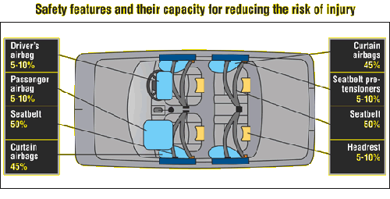Diagram and Information courtesy of Folksam Research, 2005 (SWEDEN)

(2 mark)

“Modern cars protect drivers and passengers in frontal, rear and offset crashes by using crumple zones to absorb crash energy.”

Explain the energy transformations that occur when a car’s crumple zone absorbs energy in a crash.

**EK of car (1 mark) is converted to noise, heat and deforming (2 mark)**

(3 marks)

Compare, quantifiably, the difference in car accidents between two cars, the first car weighing 1800kg travelling at 45km/h & the second car weighting 1200kg travelling 60km/h where they both hit an object and both of their final speeds are 0km/h.

**Car 1: m=1800 v car.1 = 12.5 m/s EK.car.1 = mv2/2 EK.car.2 = 1.41 x 105 J**

**Car 2: m=1200 v car.2 = 16.7 m/s EK.car.2 = mv2/2 EK.car.2 = 1.67 x 105 J**

**(2 marks)**

**Energy difference is (1.67 x 105-1.41 x 105) = 2.6 x 103 J (1 marks)**

|  |  |  |  |  |  |  |
| --- | --- | --- | --- | --- | --- | --- |
|  | **m** | **v** | **u** |  | **Ek = m/2 (v2 - u2)** | |
| **Car 1** | **1800** | **12.5** | **4.16** |  | **125000** | **J** |
| **Car 2** | **1200** | **16.6** | **4.16** |  | **156250** | **J** |
|  |  |  |  |  |  |  |
|  |  |  |  | **∆E** | **31250** | **J** |
|  |  |  |  |  | **125%** |  |

(4 marks)

Crumple zones also reduce the force experienced when a car crashes. Explain, using Newton’s Second Law (momentum) how this acts as an additional safety feature in a car.

**Newton’s Second Law commonly written as F = ma 1 mark**

**Can be rewritten as F = (mv – mu)/t 1 mark**

**t increases 1 mark**

**F decreases, hence less force on occupants 1 mark**

(2 marks)

Two point seat belts are belts that fit across the driver’s or passenger’s lap. The two points were generally on the floor. Modern car seat belts have a third point about shoulder height when sitting. Why is this advantageous?

**Better at keeping occupant in place 1 mark**

**Prevents body/head for going forward and hitting something 1 mark**

(3 marks)

You are in the passenger seat holding a 3.00 kg parcel on your lap. Your car is involved in a head on crash with a tree. The car speed goes from 72.0 km h-1 to zero in 0.100 s. What force is required to hold the parcel?

**m = 3 kg v = 0 t = 0.100 s**

**u = 72.0 km h-1 = 72/3.6 = 20 m s-1 1 mark**

**F = (mv- mu)/t = (3 x 0 – 3 x 20)/0.100 1 mark**

**F = 6.00 x 102 N 1 mark**

(3 marks)

Head rests reduce whiplash injuries in car crashes. Identify and use the appropriate Newton’s Law to explain why this is so.

**Whiplash is generally caused by crashes where the person is in the vehicle hit from behind 1 mark**

**According to Newton’s First Law the unrestrained head continues forward and then body “jerks” it back 1 mark**

**The head rest reduces how far back the head can snap back 1 mark**

(2 marks)

Airbags inflate and then deflate very quickly. Why?

**Inflate quickly to prevent head hitting solid object 1 mark**

**Deflate quickly to prevent suffocation 1 mark**

(3 marks)

If the two vehicles shown below have similar masses and safety features, using physics concepts, which of the two would be more dangerous for the driver if they hit a wall and why?

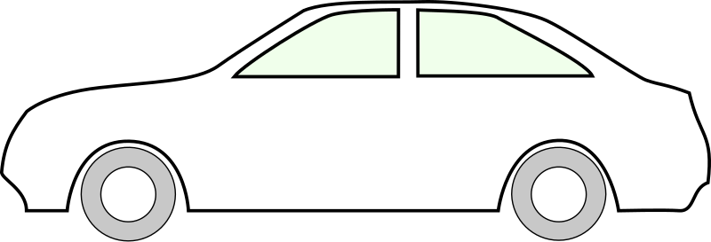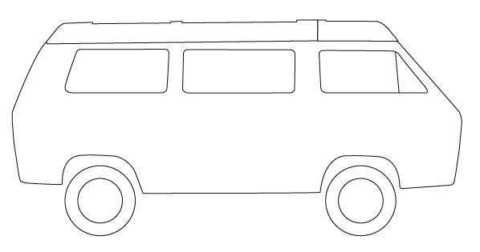

**The first vehicle (van) is more dangerous as it lacks a crumple zone. 1 mark**

**The crumple zone can absorb energy in an elastic collision, this increases the time during a crash. 1 mark**

**As the time is increased, the acceleration is decreased and the total force exerted onto the car and passengers is less 1 mark**

(3 marks)

Motorcyclists do not have this level of protection during an accident. With reference to impulse, explain how a motorcyclist wearing a helmet would increase the likelihood or surviving a high-speed collision.

**Impulse is I = F x Δt = m (v – u) therefore the impulse is fixed. 1 mark**

**The crash helmet is designed to so that the stopping time is increased by the collapsing shell during impact. 1 mark**

**This will therefore reduce the force 1 mark**

-End of Test-